Repair Café Campbelltown SA
Annual Almanac
2026
Coordinator: VAS DOLMAN
Contact: rccampbelltownsa@gmail.com
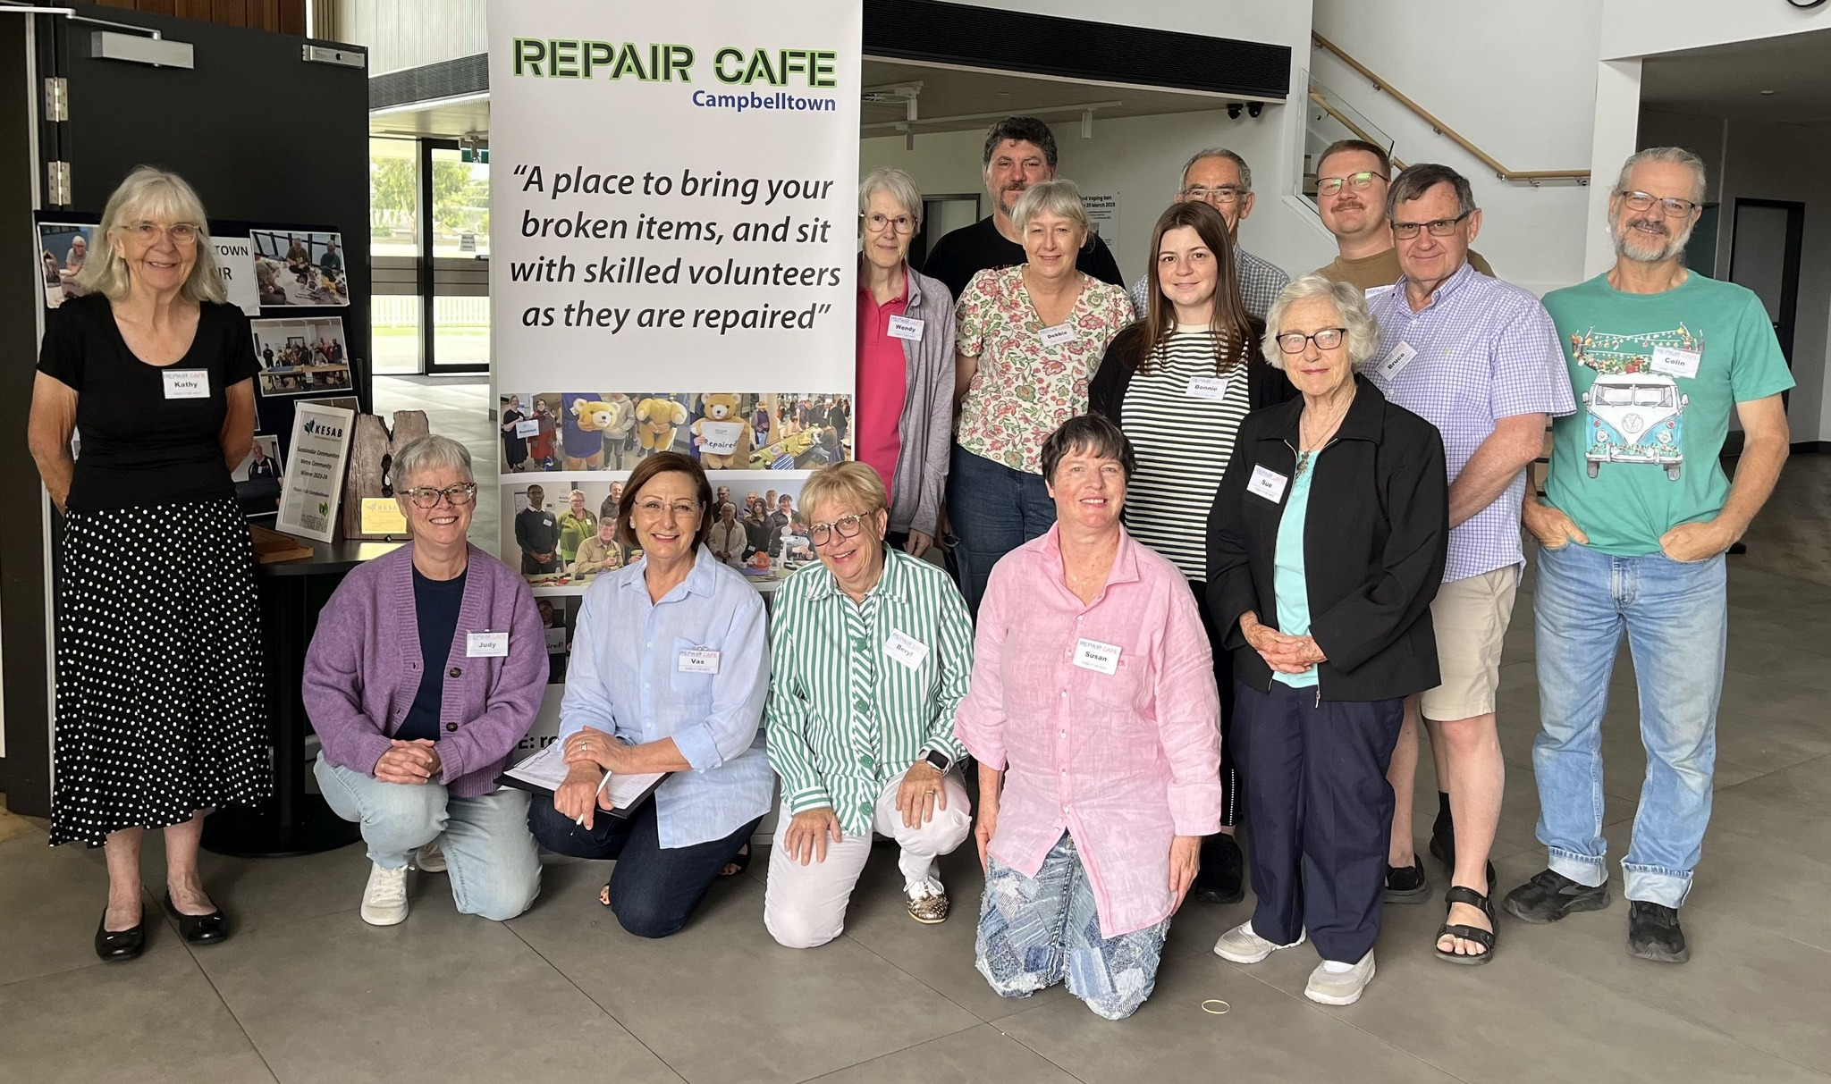
Repair Café Campbelltown SA

1. About the project
The Campbelltown Repair Café is a place you can bring your broken items for fixing – and learn how to fix them yourself with the help of volunteer repairers. The Campbelltown Repair Café is a vital, free resource in the community that aims to reduce landfill, provide opportunities to learn new skills, meet new local people, create community and save money. Each event takes place on the second Sunday of each month (except May and December).

The types of repairs available are:
- Electrical
- Textiles / Clothing / Darning
- Wooden
- Mechanical / Bicycles
- IT and Software
- Jewellery
- Tool sharpening
2. Acknowledgement and thanks (optional)
Campbelltown Repair Café is a community run initiative serviced by volunteers. It is auspiced by Sustainable Communities SA, and supported by the Campbelltown City Council
3. Highlights of the year
- Total kilograms saved from landfill approaching 3 tons
- We celebrated our 50th event milestone
- Growing our volunteer cohort
4. Events and workshops
Event title | Date & time | Location |  | Registration / contact
Repair Cafe | January 11th, 2026  9.30 – 2.00 | Campbelltown Memorial Oval |  | rccampbelltownsa@gmail.com
Repair Cafe | February 8th, 2026  9.30 – 2.00 | Campbelltown Memorial Oval |  | rccampbelltownsa@gmail.com
Repair Cafe | March 8th, 2026  9.30 – 2.00 | Campbelltown Memorial Oval |  | rccampbelltownsa@gmail.com
Repair Cafe | April 12th, 2026  9.30 – 2.00 | Campbelltown Memorial Oval |  | rccampbelltownsa@gmail.com
Repair Cafe | June 14th, 2026  9.30 – 2.00 | Campbelltown Memorial Oval |  | rccampbelltownsa@gmail.com
Repair Cafe | July 12th, 2026  9.30 – 2.00 | Campbelltown Memorial Oval |  | rccampbelltownsa@gmail.com
Repair Cafe | August 9th, 2026  9.30 – 2.00 | Campbelltown Memorial Oval |  | rccampbelltownsa@gmail.com
Repair Cafe | September 13th 2026  9.30 – 2.00 | Campbelltown Memorial Oval |  | rccampbelltownsa@gmail.com
Repair Cafe | October 11th, 2026  9.30 – 2.00 | Campbelltown Memorial Oval |  | rccampbelltownsa@gmail.com
Repair Cafe | November 8th, 2026  9.30 – 2.00 | Campbelltown Memorial Oval |  | rccampbelltownsa@gmail.com

5. Photos and captions

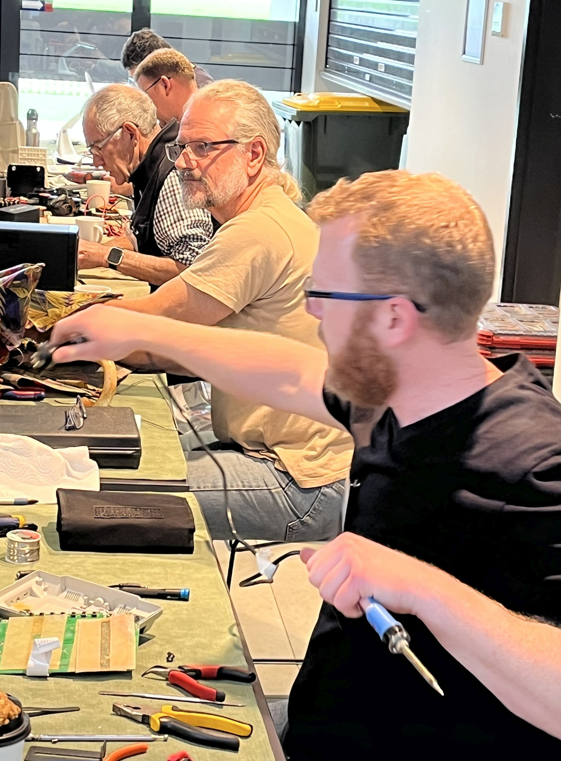
Electrical, mechanical, electronics, IT repairs
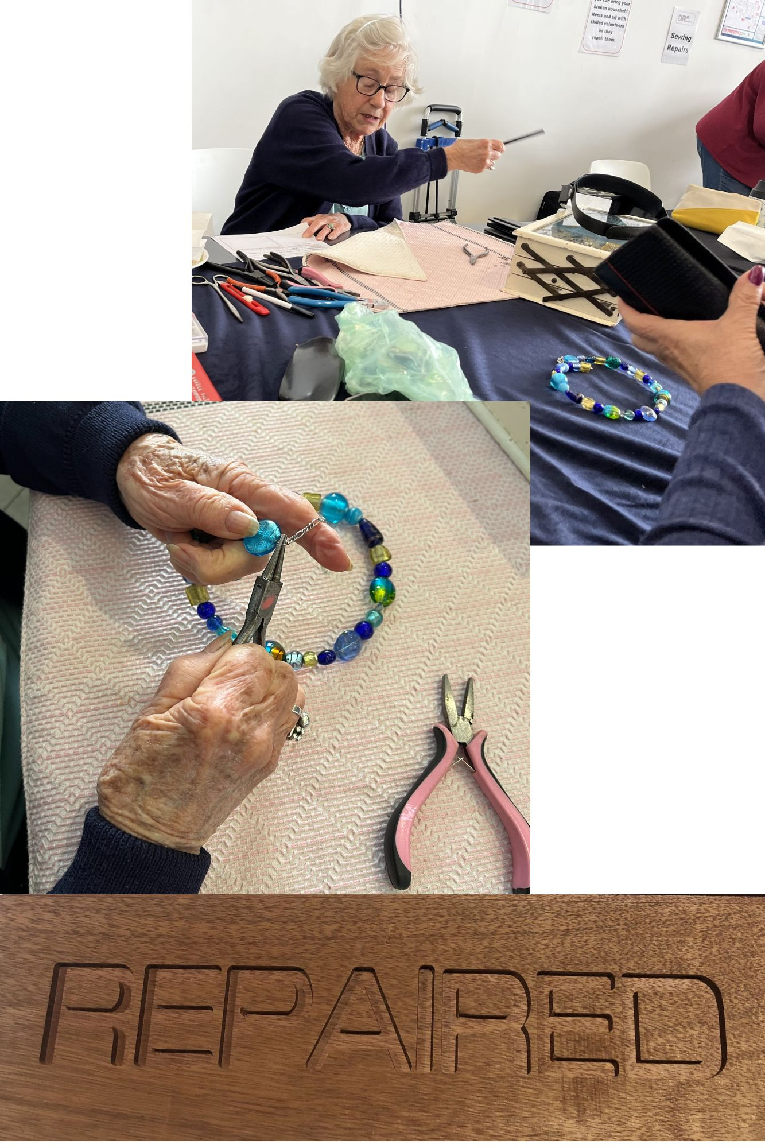
Jewellery Repairs
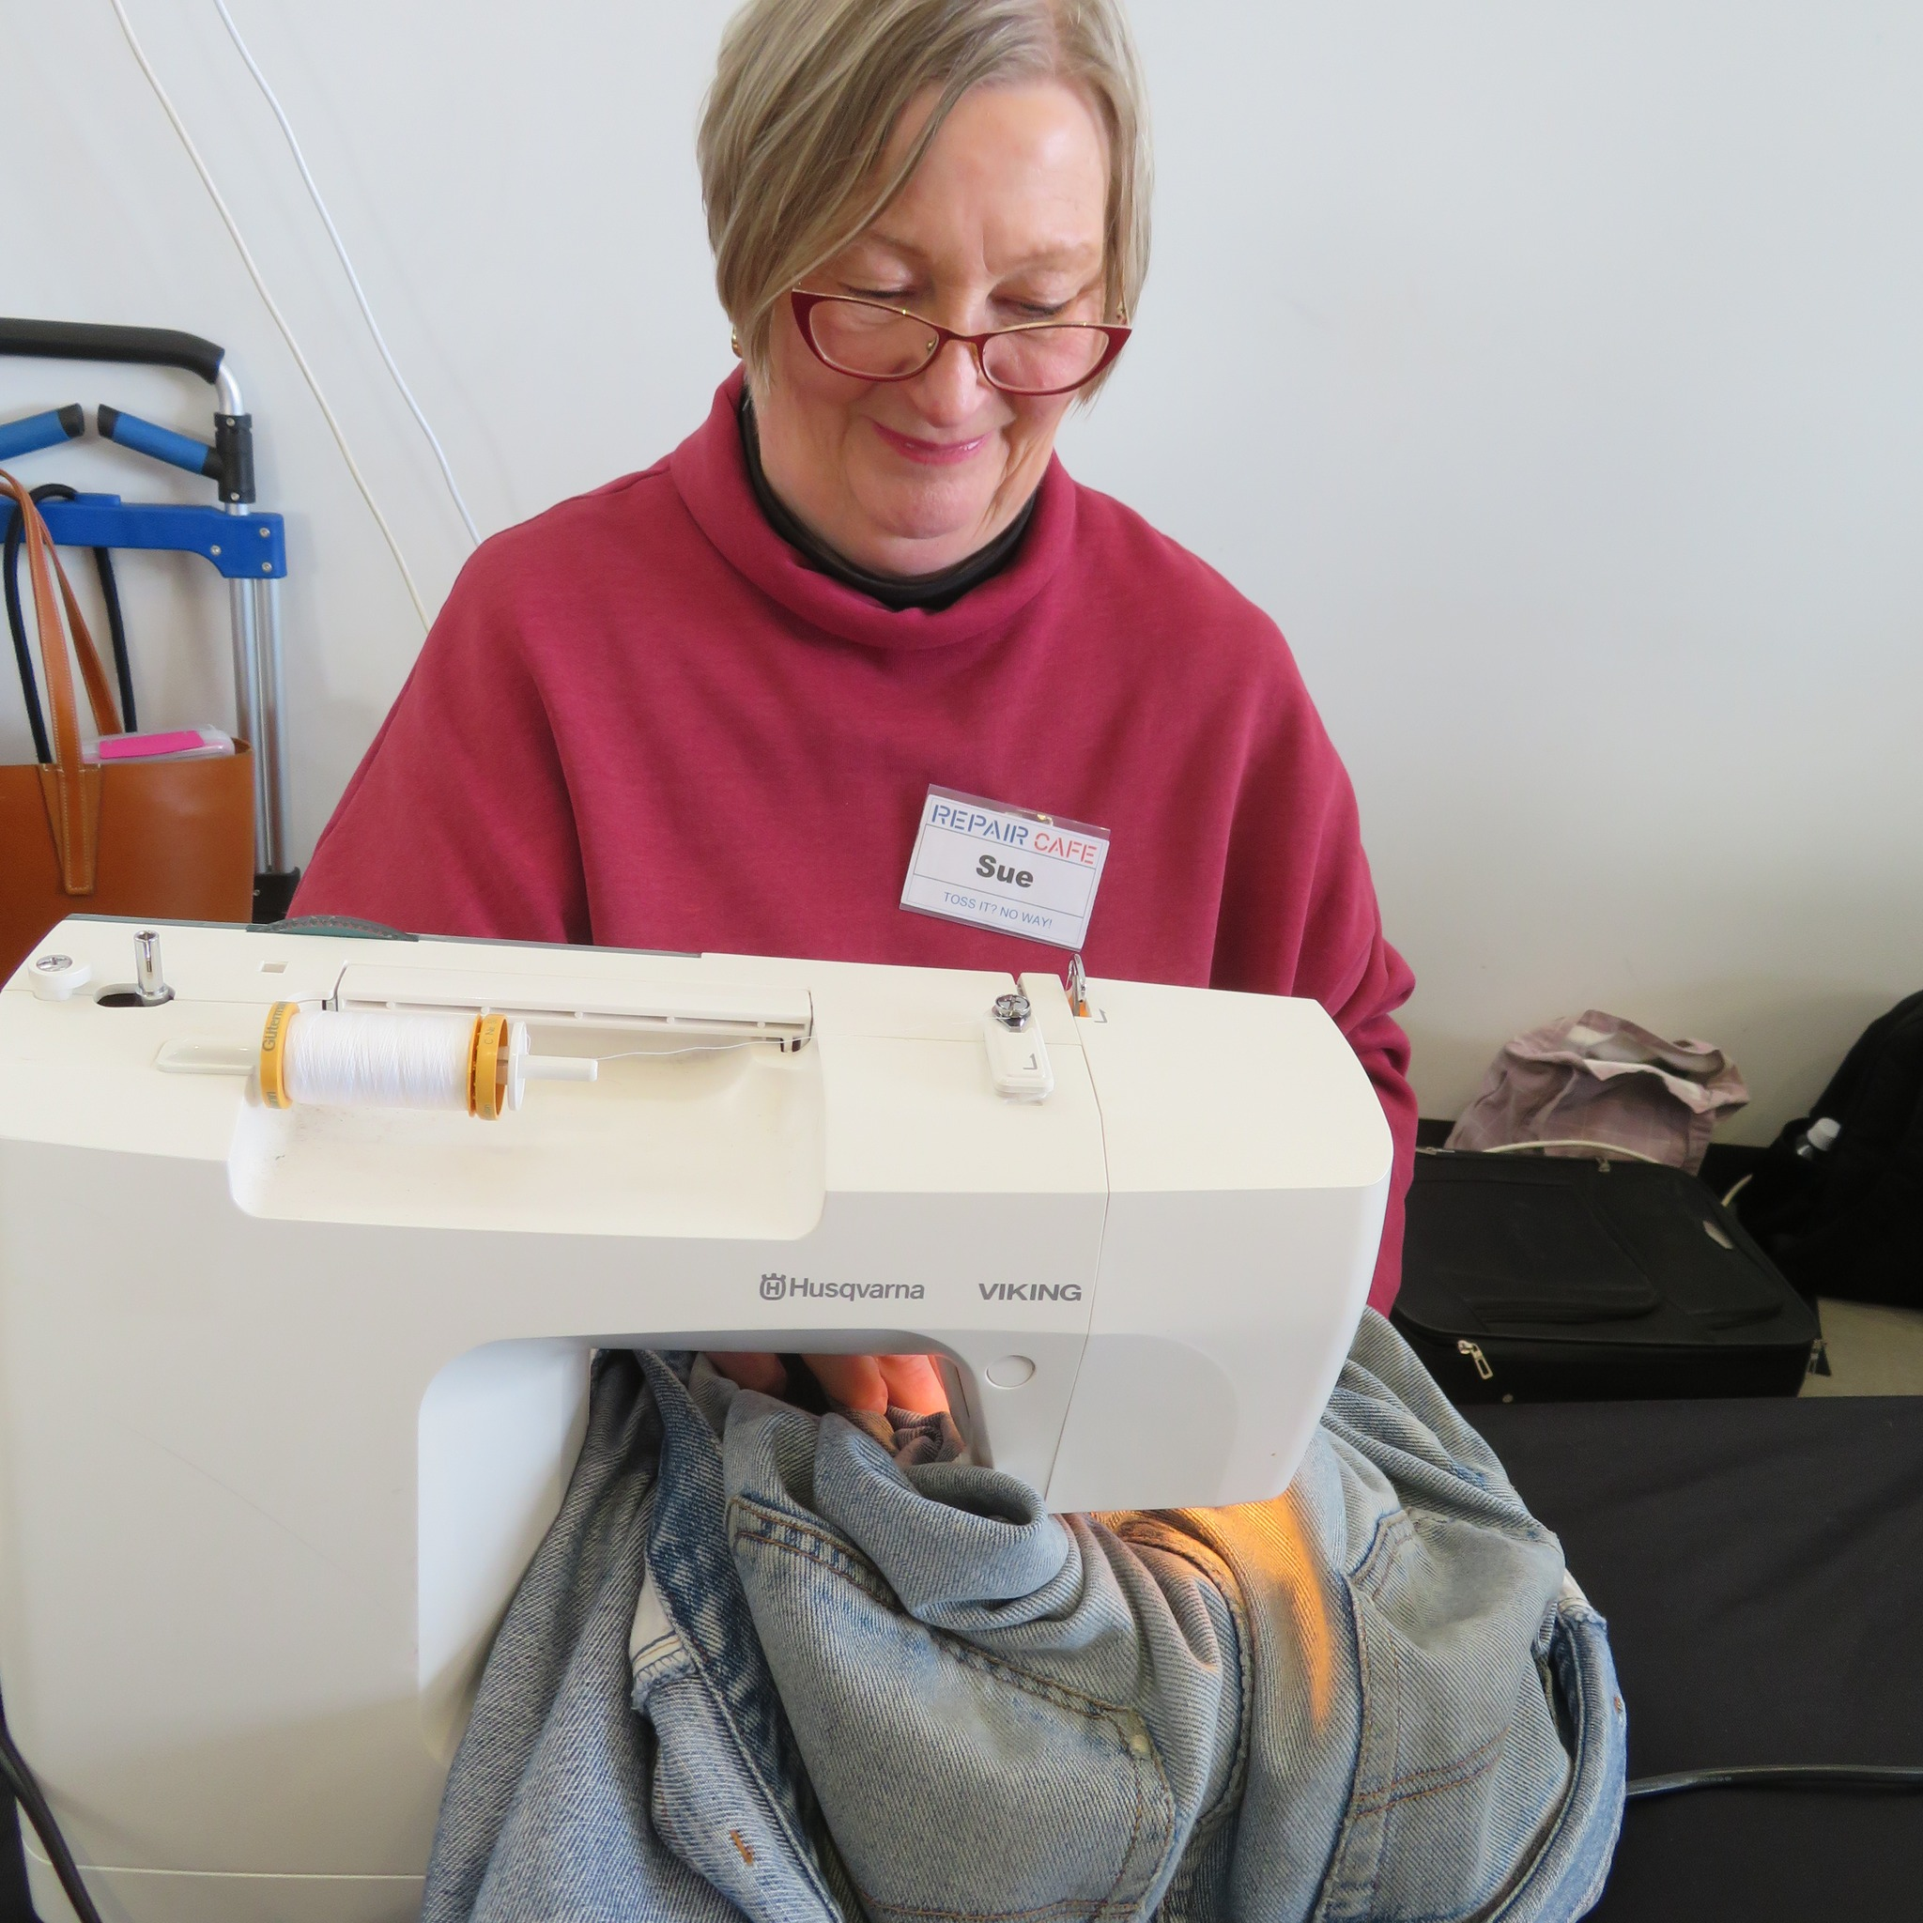
Fabric and textile repairs

8. Contact and how to get involved
Email: rccampbelltownsa@gmail.com
Facebook: https://www.facebook.com/Repaircafecampbelltownsa
How to join:
The success of the Repair Café in Campbelltown depends on community involvement. You don’t have to have repair skills to help – there are several roles available

